You have spent 11,903,243,243 years in the underworld. It is hot but you’ve gotten used to it by now. But now, you have grown tired of staring at the stalactite and stalagmites that adorn your cavern. You flutter out of your little hovel. In front of you is your neighbor, Sally Mander. Once again, he is slithering around, rubbing his belly all against your flowers.

**(if you gnash your teeth)**

Your neighbor gnashes his teeth back at you. Ouch! Battered and confused, you flutter to your go-to deli. Probably the best deli in the underworld if you were to ask me. What do you do? **(50% chance)**

Your neighbor screams out of fear and drops one Solar Flare Crystal. Nice. These are useful because just about everything is mean to you in the underworld. Happy with yourself for scaring away your neighbor of 11,903,243,243 years, you flutter to your go-to deli. Probably the best deli in the underworld if you were to ask me. What do you do? **(50% chance)**

**(if you flutter away)**

Your neighbor screams out of fear and drops one Solar Flare Crystal. Nice. These are useful because just about everything is mean to you in the underworld. If you encounter someone that you are scared of, feel free to use one of these babies to blind them. Not really sure the science behind these orbs but I have learned not to question this sort of stuff. It is easier that way.

You flutter to your go-to deli. Probably the best deli in the underworld if you were to ask me. What do you do? **(50% chance)**

You spot a pocket knife on the ground as your flutter away from your neighbor. Nice! Pocket knives are a great way to defend yourself or attack someone in the underworld. Use this when you feel cornered or threatened or violent if it behooves you. Feeling feisty, you flutter to your go-to deli. Probably the best deli in the underworld if you were to ask me. What do you do? **(50% chance)**

**(if you use Solar Flare)**

As you blind your neighbor, you spot a pocket knife on the ground. Nice trade-off! But be careful, you now consumed a Solar Flare crystal. But hey, you really wanted to blind your neighbor, more power to you. It’s the underworld after all. Pocket knives are a great way to defend yourself or attack someone in the underworld. Use this when you feel cornered or threatened or violent if it behooves you. Feeling feisty, you flutter to your go-to deli. Probably the best deli in the underworld if you were to ask me. What do you do? **(100% chance)**

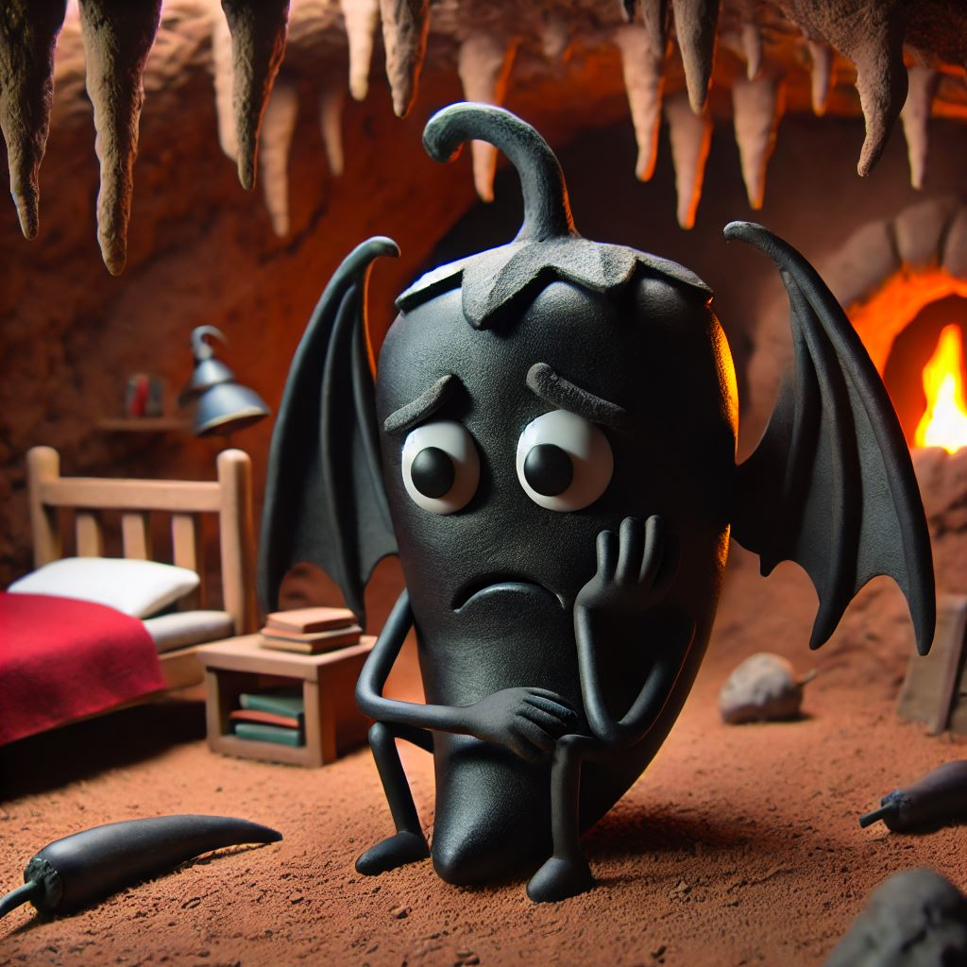

“The Deli” Story

“Hello there old friend, do you want the usual?”

Devin the Demon waves at you and pre-emptively starts making your usual Reuben but without the Russian dressing and sauerkraut. (In case you didn’t know, they can’t make sauerkraut in hell, I mean, uh, the underworld). Suddenly a very large rattling knocks over everything in the restaurant. A giant dragon exhales fire and smoke into the restaurant. Luckily, you were behind the rotisserie. A dry wind rattles your wings and you find it hard to fly. What do you do?

**(if you gnash your teeth)**

I respect your bravery but gnashing your teeth does you no good. The dragon bites you. Ouch! Be careful! Fortunately, the dragon ravages the restaurant and eats all the food. No Reuben for you. Hungry and upset, you leave the deli with an empty stomach. **(50%)**

I respect your bravery but gnashing your teeth does you no good. The dragon tries to bite you but Devin the Demon pokes him with a fork. The Dragon slithers away. Devin The Demon feeds you a Reuben which covers whatever damage you have received so far. **(50%)**

**(if you flutter away)**

80% You successfully run away.

You flutter away. Behind your shoulder, you witness the Dragon terrorize your go-to deli. You see Devin the Demon and other patrons fight for their lives as you scutter away like the coward that you are. Sorry. I take that back. You were perfectly justified in leaving those people to their demise. **(100%)**

**(if you use Solar Flare)**

The Dragon covers his eyes with his claws. Ouch! For him, not for you. Thank goodness. The Dragon cowers away and Devin the Demon hops upon his back and knocks him out.

“Looks like Dragon soup is on the menu!”

After a few hours of preparation in the kitchen, the whole restaurant receives a complementary soup that tastes nothing like you have ever had before. As you feast, you steal two pocket knives from your friend Devin the Demon who was busy refilling your drink. Before he comes back, you leave. You’re going to need these knives for your journey. **(65% chance)**

Ouch! You blinding the dragon with a very bright light made him furious. He swipes at you as he hobbles out of the restaurant. Devin the Demon thanks you for protecting his restaurant but doesn’t offer any sort of recompense for your brave deed. So you leave the restaurant without paying. **(35% chance)**

**(if you use Pocket Knife)**

100% You successfully run away.

**Miasma Story**

You fly along Crimson Street. Taking in your old stomping grounds. No time to be nostalgic. You feel something disturbing within your gut. You think that it is self-doubt of your decision to finally leave the underworld but in actually it is a miasma force tugging your life energy. But it could be self-doubt too. You *are* making a big decision so it is understandable. But enough of that. A giant miasma floats in front of you and if you don’t act soon, your energy will be completely sapped! You definitely don’t want to see if there is an afterlife beyond the afterlife. The Menacing Miasma. You’ve always heard folklore about it but never in your wildest dreams would you have ever thought that you’d encounter in on the Crimson Street. It calls your name and states all your personal information out loud. What do you do?

**(if you flutter away)**

You successfully flutter away from the miasma without too much of your soul gone missing. **(35%)**

You successfully flutter away from the miasma without too much of your soul gone missing. In fact, you feel much better and stronger now that you have lost a part of your soul. **(10%)**

You successfully flutter away but your wings feel heavy. You trip on a bunch of nasty pointy rocks during your exit. **(25%)**

You successfully flutter away but your wings feel heavy. You trip on a bunch of nasty pointy rocks during your exit. You find a Solar Flare Crystal thankfully. Finally, some good luck! **(15%)**

You successfully flutter away but your wings feel heavy. You trip on a bunch of nasty pointy rocks during your exit. You find a pocket knife underneath some rocks. Finally, some good luck! **(15%)**

**(if you gnash teeth)**

You gnash your teeth and it does nothing. The miasma is unphased. As you stand there gnashing your teeth, you feel your soul drain from you and you faint. No wait. You more than just faint on the ground. You just died. You don’t wake up. Nice going. Maybe next time don’t stand around the soul-sucking miasma like a doofus. **(50%)**

You gnash your teeth and it does nothing. The miasma is unphased. As you stand there gnashing your teeth, you feel your soul drain from you and you faint. You wake back up missing a few things. You brush the dirt off your wings and you continue onward. **(50%)**

**(if you use Solar Flare)**

You perform a successful Solar Flare. The miasma melts onto the ground and in its remains, you spot a pocket knife amidst all the goo and gunk. Debatable trade-off but good for you. At least you didn’t stick around and gnashed your teeth. That would’ve been the worst possible decision. You continue onward. **(85%)**

You perform a successful Solar Flare. Or at least you think you did but the miasma expands and eats a part of your wing. Ouch! You scramble away, hiding behind a boulder, waiting until the enraged miasma cloud to leave. You continue onward onto the Underworld Expressway. **(15%)**

**(if you use Pocket Knife)**

100% The knife does nothing.

You wave the pocket knife in the air. The miasma consumes your knife and the hand that wields it.v Ouch! You *do* know what a miasma is right? Why did you think you could stab it? Would’ve been better for you to run away. But whatever. Hopefully you learned your lesson. You hide behind a boulder until the miasma hovers away. You continue onward onto the Underworld Expressway.

On the Underworld Expressway, you encounter a traveler wrapped in black clothes. He looms over you. He studies your wings. Strange bizarre tattoos all over his arms with otherworld meanings.

“Oh be kind to me, traveler on thy dirt road.” This traveler’s breath stinks and is overall unpleasant to be around.

What do you do?

**(if you gnash your teeth)**

The traveler sighs and stammers away from you. I think I hear him sniffle a bit. You really broke his feelings. You know, not everyone in the underworld is out to attack you. Anyways, you see a fork in the road. You take the road that leads you to Desolate Village. **(20%)**

“Ahhh!” The shrouded traveler in black screams and pokes you with his own pocket knife. Ouch! The traveler runs off towards the direction of Desolate Village. You probably don’t want to deal with him again. He’ll probably attack you again so you head towards Wild City, the city of endless debauchery and sin. **(20%)**

“Well put, young traveler, hold your snarling for you will need to save your energy. There is a more dangerous man out on the road who goes by the name Mr. 12. They say he roams the highest heights of the underworld, attacking anyone who seeks to escape it. Whatever you do, use your resources against him if you ever find yourself in his grasp. They say that Mr. 12 is the man stuck in time. Space is neither an obstacle for him and he will find you no matter how much refuge you seek. Whether you to a left onto Desolate Village or right onto Wild City, the cursed city of endless debauchery and sin, Mr. 12 will be able to find you if it is on his list of desires. On that note, I wish you luck.” After heeding the words of the stranger, you follow him into Desolate Village. But not for long, you look into the direction of two tall spires of the Wild City you avoided and you turn back towards you companion only to find him gone. **(60%)**

**(if flutter away)**

“Well put, young traveler, you should trust no man on this road for there is a more dangerous man out on the road who goes by the name Mr. 12. They say he roams the highest heights of the underworld, attacking anyone who seeks to escape it. Whatever you do, use your resources against him if you ever find yourself in his grasp. They say that Mr. 12 is the man stuck in time. Space is neither an obstacle for him and he will find you no matter how much refuge you seek. Whether you to a left onto Desolate Village or right onto Wild City, the cursed city of endless debauchery and sin, Mr. 12 will be able to find you if it is on his list of desires. On that note, I wish you luck.” After heeding the words of the stranger, you follow him into Wild City. But not for long, you look into the direction of flat plains of Desolate Village, the empty town where men wither of thirst and hunger. Thankfully you have avoid that den of death. You turn back towards you companion only to find him gone. **(100%)**

**(if you use solar flare or pocket knife)**

100% The traveler falls on the ground. You find a first aid kit.

The traveler electrocuted by your sudden act of violence pops into the air and vanishes. Um. Okay. I don’t know what his deal was. But I highly doubt that he could’ve provided you with any valuable hints or foreshadowing if you picked any other option. Definitely not. Anyhow, you come across a fork in the road. Either you take the left and enter Desolate Village, the infamous den of death, or you enter into Wild City, the cursed city of endless debauchery and sin. Both don’t really sound that appetizing. You spot a truck and you are able to hitch hike.

“I’m going to the casino! But I will take you only as far as I want to.”

You drive past Wild City, out of the window, you see why it has earned its namesake. Thank goodness you were able to skip all that. The truck driver drops you off

**Desolate Village Story**

Wow. Desolate Village really is desolate. Not a soul is around. No reason to watch your back or anything…Right? I believe so but I have been wrong on these types of matters. Anyhow, you decide to rest up. Finally, a well-deserved reprieve. Your health points increase by two. You look upward. The sky only becomes redder from here. Along the walls, you see graffiti.

“Beware of the man with no shadow.”

Thankfully, you have forgotten how to read since this is your millionth something year in the underworld so the written word doesn’t mean much to you. At the tail end of the ghost town, you see a tiny shed hidden underneath tumbleweed and cacti. What do you do? (Flutter = Inspect…Gnashing Teeth = Ignore)

**(if you gnash your teeth)**

Inside the shed, you find a pocket knife. Nice! You immediately exit the shed because once you pick up the knife, a salamander slithers up and nearly bites your hand. **(25%)**

Inside the shed, you find a solar flare crystal. Nice! You immediately exit the shed because once you pick up the knife, a salamander slithers up and nearly bites your hand. **(25%)**

Inside the shed, you find nothing. Except for a salamander that bites you. Ouch! **(50%)**

**(if you flutter your wings)**

You ignore the desolate shed and continue on the road that leads up. Your old village is now a speck. You really have gone far. Hopefully you don’t encounter any more foes. Eh. Who am I kidding. There are worst things to come. I am sure glad that I am not in your place right now. The coldness of the underworld drains your breath away and your wings feel heavier every minute. Along the road you see another shrouded figure. Not sure if this is the same fella from before or not. What do you do?

**Wild City Story**

You arrive in Wild City and it really does live up to its namesake. A dozen people try to steal and mug you but thankfully you are nimble and quick. In your never-ending sprint to avoid being mugged, you hear rumors of a safe hostel for you to rest at. But the guy that you hear this from was trying to take a bite out of your wings so his credibility is questionable. But this is Wild City of all places. This could be a trap but your wings feel awfully heavy. What do you do?

(Gnashing your teeth = Enter the hostel. Flutter Wings = Stay vigilant and continue onward)

**(if you gnash your teeth)**

Good call. You enter the hostel and a merry crowd celebrates your presence. You rest up with a good meal. You eat so much that you sleep for three days straight. Once you wake up, you feel the healthiest that you have ever been. You wish you could eat that hostel’s good cake and drink its delicious ale but you left your cave for a reason. You see yourself falling into the same traps that you have fallen back home in this city of endless debauchery and sin. There is a place greater than here. You shake yourself awake from the hypnotism of Wild City. Your friends wish you goodbye but before you leave. They gift you a pocket knife. **(10%)**

Good call. You enter the hostel and a merry crowd celebrates your presence. You rest up with a good meal. You eat so much that you sleep for three days straight. Once you wake up, you feel the healthiest that you have ever been. You wish you could eat that hostel’s good cake and drink its delicious ale but you left your cave for a reason. You see yourself falling into the same traps that you have fallen back home in this city of endless debauchery and sin. There is a place greater than here. You shake yourself awake from the hypnotism of Wild City. Your friends wish you goodbye but before you leave. You thought they were going to give you something. You really had the impression that they were going to but they shut the door immediately after you step out of that hostel. Whatever. You continue onward. **(40%)**

An unspeakable unfathomable host of darkness towers over you. The man of pure shadow. The infamous and moral-less hunter of the underworld, Mr. 12 yanks you by your wings and uses your teeth as a toothpick. All the music and the mirth pauses. The Wild City comes to a halt and watches Mr. 12 tear down skyscrapers upon you. Ouch! Bricks fall upon you as Mr. 12 plays with you. You don’t know what you did wrong. **(50%)**

The man stuck in time grabs you by the wings. Tears both of them to shreds. Ouch! You lost your ability to flutter. You find it hard to see for your body gets tossed around like a football in that terrible city. Who knows where you are taken to. You hear the beat of drums and you hear the heat of a bonfire. Folks laugh at your misery.

Mr. 12 hoists you up in the air with his giant gloved claws.

“Keep going. I dare you.”

He leaves you with a pocket knife and a solar flare crystal. You wake up in a bed of bricks completely displaced from the Wild City. You are barely alive but you keep going. Might as well. You have come this far. Hopefully you won’t meet this Mr. 12 fellow ever again but you know you will.

**(if you flutter away)**

You ignore the city as it calls for you. Maybe you did good or maybe you did bad. Who knows what could’ve happened to you in the Wild City. You stay on the path ahead. **(%100)**

**Mr. 12 Encounter Story**

On your travels, you pass a man limping. You believe him to be the fella from before who had asked you for help. As you turn around, you realize that a giant hand is around your throat and he begins to choke you. It is Mr. 12, the fabled hunter of the Underworld! Quick! What do you do!

**(gnash your teeth)**

You gnash your teeth. Wrong move, my friend. Within seconds, you see yourself on his wall of many trophies. Chained up and a prisoner to this terrible man of the underworld. Your goal was so close. It truly was. You only had a handful of choices left in this game but you made the wrong decision. You were so close but now you are leagues away from your goal. Wingless, teethless, and defenseless, you sit in Mr. 12’s cell for eternity. Unless you try again and remember to not gnash your teeth at Mr. 12. **(100%)**

**(if you flutter away)**

You try to fly away. Wrong move, my friend. Within seconds, you see yourself on his wall of many trophies. Chained up and a prisoner to this terrible man of the underworld. Your goal was so close. It truly was. You only had a handful of choices left in this game but you made the wrong decision. You were so close but now you are leagues away from your goal. Wingless, teethless, and defenseless, you sit in Mr. 12’s cell for eternity. Unless you try again and remember to not gnash your teeth at Mr. 12. **(30%)**

You try to fly away. Mr. 12 grabs you wing and eats it. Ouch! You fall into a ravine. Double ouch! Mr. 12 laughs as he watches you writhe and get carried away by a stream. Surprised that you are still alive, you sleep for ten days, nearly comatose. Out of hatred for Mr. 12, you whittle a pocket knife out of the rocks of the ravine. **(70%)**

**(if you solar flare)**

50% Mr. 12 drops you.

Smart thinking. Your Solar Flare blinds Mr. 12. He hobbles backwards down a ravine that you didn’t even know was there! You fly away because you know surely that a fall won’t take down a man…no, a beast of this stature. **(70%)**

Smart thinking. Your Solar Flare blinds Mr. 12. He hobbles backwards down a ravine that you didn’t even know was there! You fly away. Somehow, your Solar Flare crystal still remains in your palm. It seems like you can reuse it! Wow. What luck! You’ll surely need it because you know surely that a fall won’t take down a man…no, a beast of this stature. You continue onward.

**(if you pocket knife)**

Mr. 12 curses and hunches over, dropping you, providing you a blissful seconds to escape. But you smell something off. You smell…wood? Sawdust mixed with cigarette smoke. No time to linger! What are you doing! Get out of there!

You narrowly escape the maws of that terrible hunter. You feel like that won’t be the last time that you will see him. **(70%)**

Mr. 12 curses and hunches over, dropping you, providing you a blissful seconds to escape. You narrowly escape the maws of that terrible hunter. You feel like that won’t be the last time that you will see him. **(30%)**

You sleep in a cardboard box. The dry wind that batters you box keeps you awake. Which is good because you know that not for the wind, then terrible nightmares of Mr. 12 will haunt your dreams. His disfigured face haunts you still. Once morning comes, you head upwards and you see a haven of flickering lights. Oh no. The Casino of Casinos. You have heard rumors of this terrible place. The place where millionares become peasants. The underworld’s finest have found themselves humbled here. Almost dead and dehydrated, you reluntantly approach the casino for something to drink. You’d drink just about anything at this point. Neon signs onslaught you as you approach the bouncer. The bouncer peeks at your inventory and smiles.

“Heh. Come on in.”

Billions of souls hover in the air, betting parts of their consciousness to win. Souls rendered miniscule. They have gambled fractions of their soul at cards. In this casino, you can bet your Pocket Knives, your Solar Flares, and even your ability to flutter away and gnash your teeth. But be careful, Mr. 12 could still be out there. But your thirst overwhelms you. In order to have a drink, you must play by the house’s rules and pay the cost of admission. You go up to the dealer. His name, Jacques, seems to know exactly what you want and pours a nice glistening bottle of champagne.

“If you win a nice glass of champagne on the house. If you lose whatever ability of yours that you offer me. Heh heh.” Jacques rubs his lips and licks his hands.

“What you bettin’?”

**(if you win)**

Jacques pours you a nice refreshing glass of champagne. Once the liquid hits your lips, you immediately forget the terrors that have led up to this point.

Do you want to go again? (If you go again, you have the opportunity to double your max HP)

**(gnash your teeth)**

50% You win a bottle of champagne. Your health increases by one.

50% You lose your ability to gnash your teeth. You get offered a bottle of mud water. You lose one hp.

**(if you flutter away)**

45% You win a bottle of champagne. Your health increases by one.

45% You lose your ability to flutter away. You get offered a bottle of mud water. You lose one hp.

10% Mr. 12 storms into the casino and strangles you. (Mr. 12 attack scenario).

**(if you solar flare)**

45% You win a bottle of champagne. Your health increases by one.

45% You lose your ability your solar flare ability. You get offered a bottle of mud water. You lose one hp.

10% Mr. 12 storms into the casino and strangles you. (Mr. 12 attack scenario).

**(if you pocket knife)**

45% You win a bottle of champagne. Your health increases by one.

45% You lose your pocket knife. You get offered a bottle of mud water. You lose one hp.

10% Mr. 12 storms into the casino and strangles you. (Mr. 12 attack scenario).

You are no longer dehydrated and you exit that terrible casino. Souls wither as fast as they enter. In the corner of your eye, you spot Mr. 12 roaming the aisles of slot machines. Quick. Hide. You see a janitor’s closet but it has a word-lock in it! Do you have any idea what the password is?

If you guessed the right password:

You unlock the door. A chamber holding golden trinkets, elaborate paintings of an age far gone, and a throne. Mr. 12’s room. Darcy, the Janitor of Time, lives here in the casino. Besides you, you see a cage with a crying heart. A teal costume.

“Oh please, let me out. I beg you.”

And you do so, as a reward, the man known as Mr. Heart bestows upon you a pocket knife. “I do not know who you will face next, but be careful. Here is an old poem that will help you.”

In the painting you see a portrait of a young janitor chain smoking two cigarettes. The next you see a grave with a giant Tabacco pipe laying on its left side, and in the third portrait, you see an old factory worker keeled over. Odd artwork that’s for sure. You leave the locked room when Mr. 12 walks past. You finally leave the casino.

**(if all the requirements have been met) (this includes Darcy receiving two cigarettes, Darcy the Toy Worker being killed, and Darcy’s Grave receiving a pipe on the left.)**

**You see a vortex in the sky and a giant furball hops from the sky. A rainbow bridge descends down in front of the casino. You don’t know what is going on but the Furball looks at you. Suddenly, Mr. 12 marches towards the both of you. Furball joins your team.**

**(if none of the requirements have been met)**

**Oh the skeletons of old scuttle away when the sun comes,**

**Like a large king who has long dwelled hell but his flesh still bends,**

**Or like the gargoyle who hates teeth that is sharper than his,**

**Old stone soldiers whose feet shapes thy ground but arms cannot even reach the air!**

**But that terrible Mr. 12, thy Janitor of Time, use pocket knifes to end him this time.**

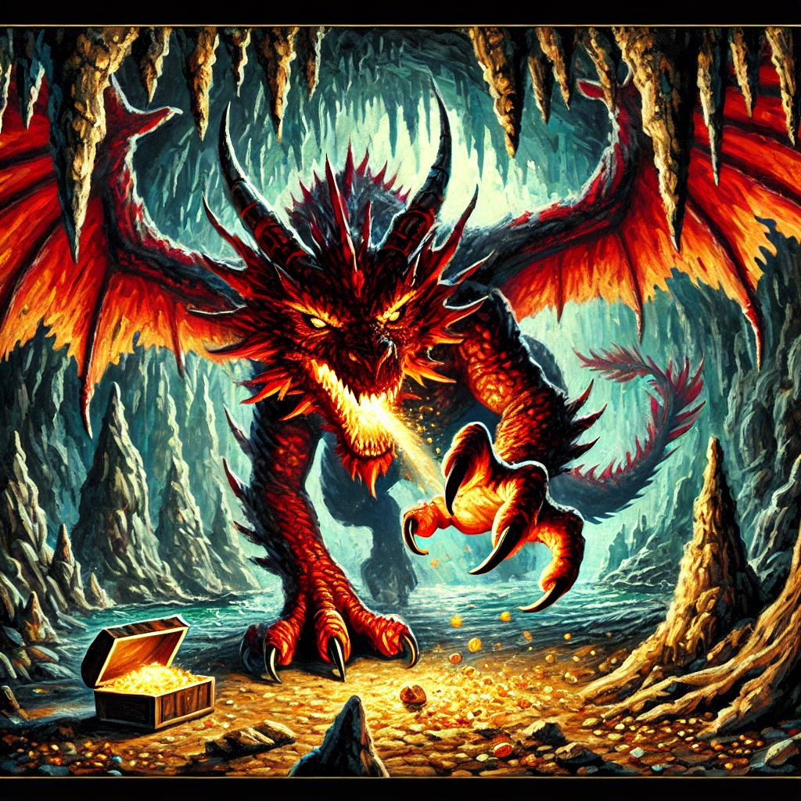

(The store keeper is Scar D. Cat or Stu Pit)

That’s enough casino for today or ever. You flutter out of the casino. What are you trying to do again? Oh yeah, get out of the underworld. After days of wandering on the road (There is only one road in the underworld. Very convenient actually), you meet a lemonade stand that oddly enough is selling pocket knives and Solar Flare Orbs in addition to lemonade. What do you do?

**(gnash your teeth)**

45% The store keeper cries and runs away. It turns out that the store keeper is a massive scaredy-cat. You pick up two pocket knives.

45% The store keeper grabs you by your wings and uses you as a toothpick. Ouch!

10% The store keeper gnashes their teeth back at you. You flutter away.

**(if you flutter away)**

100% Nothing.

**(if you solar flare)**

(if the store keeper is Stu Pid) 55% When you are about to use your own solar flare, you realize that the solar flares are locked in a vault. You ask the storekeeper to unlock the vault so you can see if they are real. The storekeeper does so

(if the store keeper is Stu Pid) 35% You use solar flare on the store keeper and he falls onto the ground. You loot his inventory. A gallon of lemonade heals 1 HP and you get a pocket knife. You realize that the Solar Flare orbs are locked in a vault.

(if the store keeper is Scar D. Cat)

100% Scar D. Cat swipes at you and picks up his shop and leaves.

**(if you pocket knife)**

**100%** if you pocket knife. The knife does nothing to his rock-iron body. Stu Pid. He grabs you by the wings and uses you as a toothpick. Ouch!

**100%** if you pocket knife, Scar D. Cat. The cat scampers away. Leaving his store to your discretion. You heal 1 HP, collect a fresh pocket knife and even get to keep the one that you just brandished! But unfortunately, you cannot brake open the Solar Flare vault. You hear Mr. 12’s infamous jingle and you flutter away.

You have walked very far and the amount of souls that you see lingering dwindle until you are the very last one. You should feel very proud of your luck so far. But be careful, the kindness and generosity of the underworld does not correlate with how much deeper you go. You now stand in front of a castle crafted out of brimstone. Judging from the ornate decorations, you can tell that this must be the ruler of the Underworld. Maybe you can ask the owner if he can whisk you out of the underworld. Who knows, you’ve seen a lot of things happen today. You enter the king of the underworld’s castle and the king will be with you shortly. So in the meantime, rest up in one of the castle’s many rooms. Now, you don’t remember what room the guard told you to enter. Was it the blue room, red room, yellow room, or the green room?

**If blue room selected =>**

50% Stone Golem Ending

50% Large King Ending

**If red room selected=>**

50% The Large King Ending

50% Gargoyle Ending

**If Yellow Room Selected =>**

40% Skeleton Ending =>

10% No boss fight =>

50% Gargoyle Ending =>

**If green Room is selected =>**

50% Skeleton Ending =>

50% Stone Golem Ending =>

What? This isn’t a bedroom. This is a giant chamber. A sleeping gargoyle wakes and becomes disgusted at the sight of you.

“Get away! You smell of him!”

You couldn’t refute or explain yourself before the gargoyle charges at you. What do you do?

5 Stone Golems awaken as you flutter into the room. Mold and moss flakes float off their gigantic ancient arms as they grasp for your frail wings. Judging how everything in the underworld has the tendency of attacking you, their slow movement towards you does not seem inviting. What do you do?

As you step into your bedroom to finally relax after what seemed like a never-ending trek, you are not finished yet. Inside your bedroom is a large fleshy king adorned in a robe crafted out of otherworldly silk.

“Oh no! No no no no!” The king heaves off the bed and storms towards you. “You will not seek council with the ruler of the underworld!” You have no idea how intense things are going to get. Is this guy just joking around. W-What do you do?

A skeleton wiggles out of the ground. Seems harmless enough. Until you realize that a whole swarm of them are wiggling out of the ground and they flood your room like water. Three little skeletons dance around the place. You blink and now there are twelve. You better act fast because now there are thirty six of them prancing around. What do you do?

You look at the four doors and you realize that none of them are for you. But rather, the 5th door that seems to have been there the entire time. “TRUE ENDING” room. I think this is the room you are looking for. Good job. You look at the framing of the door. Something or someone must’ve helped you reach this door because you feel like someone has. When you pull the handle of the door, you don’t have enough strength to do so. Until someone who you have never seen before helps you.

The furball joins you. Without asking any questions, you two seem to have an understanding of each other. The two of you heave the heavy door open and you see Mr. 12 charging towards you.

**(Pepper’s HP gets eight points and you enter into a battle with Mr. 12 First Form)**

**(gnash your teeth)**

Mr. 12 tears into you. You take two damage! What do you do now!

**(if you flutter away)**

No running. Mr. 12 tears into you.

25% chance of taking 2 damage.

75% chance of taking 1 damage.

**(if you solar flare)**

Mr. 12 winces and places sunglasses on. I don’t think you should try that again.

**(if you Blizzard Knife)**

80% Mr. 12’s attack power decreases. He can no longer achieve critical hits on you. You really made him mad. You **continue onward into the hall.**

20% Mr. 12’s power decreases but the attack seems ultimately useless. You **continue onward into the hall.**

**(if you pocket knife)**

Mr. 12 winces and retreats. You **continue onward into the hall.**

As you venture further into the castle, you see portraits of a Janitor, a factory worker, and a ghost. Further down, you see the king of the Underworld locked in a cage. And now you see Mr. 12 loading a giant missile launcher. What do you do?

**(if you use solar flare)**

You stalled Mr. 12 for one second. But the missile launcher is still loading. Don’t you have anything else you can do?

**(if you do anything other than pocket knife)**

You die.

**(if you use pocket knife)**

Mr. 12 falls backwards into a vat of lava. Good riddance. You proceed forwards and a great big door with golden handlebars. You open it. You drop all your pocket knives and solar flares that you have left. And no longer do you need to gnash your teeth. For you have escaped the underworld! Thank you for discovering the true ending!